Butser Ancient Farm
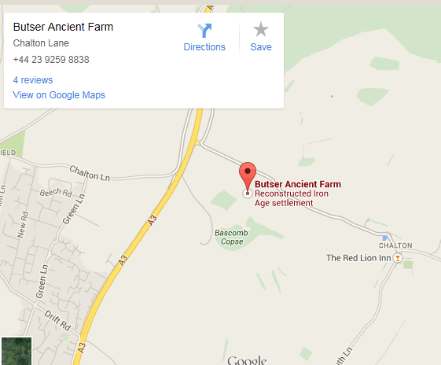
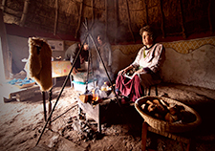
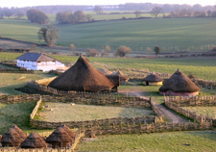
- Where is Butser Ancient Farm?
- Why might someone want to visit Butser Ancient Farm?
- List four things you could see or do at Butser.
- Would it be possible to visit Butser Ancient Farm on Saturday 17th February?
- Why do you think the writer has used text boxes?
- Why do you think the author has chosen to include a map?

When can you visit?
Butser Ancient Farm is open all year round: Monday - Friday in October to March and 7 days a week in the Spring and Summer months. 10 am – 5pm (4pm in Winter)
We are just outside the village of Chalton, near Waterlooville.
MAP
What can you see there?
Butser Ancient Farm is open to the public and to school groups. You can visit reconstructed Iron Age roundhouses and a Roman Villa. You might want to have a go at making a mosaic, doing some pottery or weaving or learning how to write in Ancient runes!
There is a lot to explore and plenty of places to eat lunch. We also have Visitor Centre and shop, where you can find out more about the site and buy a souvenir of your trip.
Butser Ancient Farm is a farm and archaeological site in Hampshire. Historians and archaeologists use the farm to try and work out how people in the past might have lived. They do experiments to work out how ancient people cooked, made things and built houses.

